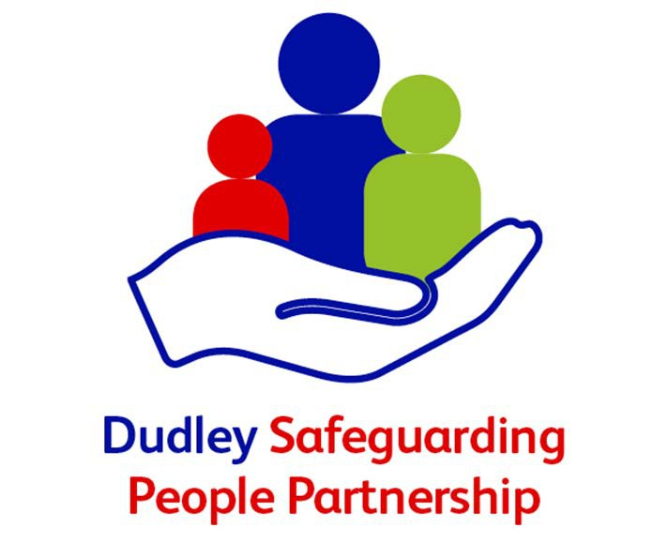

**Safeguarding Children Partnership**

**Neglect Strategy 2022-2024**

The persistent failure to meet child’s basic physical and/or psychological needs, likely to result in the serious impairment of the child’s health or development.

Working Together 2018

**Version Control**

|  |  |
| --- | --- |
| Document Title: | Neglect Strategy |
| Author: | Public Health |
| Version Dates: | v1 – 2016  v2 – April 2019  V3 July 2022  V  V3 |
| Date Approved: |  |
| Approved By: |  |
| Review Date: | July 2024 |

**Contents**

Foreword ................................................................................................................................................4

Vicky Buchanan Independent Children’s Safeguarding Scrutineer Dudley Safeguarding People Partnership

Thriving communities: our vision ……………………………………………………………………………………………………...5

Introduction............................................................................................................................................6

Purpose and scope..............................................................................................................................6

Strategic aim .......................................................................................................................................7

Objectives ...........................................................................................................................................7

Key principles......................................................................................................................................8

Neglect – The picture in Dudley .............................................................................................................9

Referrals..............................................................................................................................................9

Children in Need ................................................................................................................................10

Children Looked After (CLA) ..............................................................................................................11

Child protection .................................................................................................................................12

Child protection categories ………………………………………………………………………………………………………… 13

Neglect – The national picture ..............................................................................................................14

Neglect from a community perspective - What children, families, communities and practitioners said........................................................................................................................................................15

What is Neglect?...................................................................................................................................16

Definitions.........................................................................................................................................17

Recognising child neglect ………………………………………………………………………………………………………….. 18

Risk and Vulnerability factors ……………………………………………………………………………………………………..19

Affluent Neglect ………………………………………………………………………………………………………………………….21

Mental health outcomes ...................................................................................................................22

Adverse childhood experiences and relationship to poor outcomes................................................22

Preventing abusive head trauma (ATH)……………………………………………………………………………………….22

Neglect in special groups: SEN and children with disability ..............................................................24

Neglect in adolescents......................................................................................................................24

Responding and Assessing …………………………………………………………………………………………………………………26

Preventing neglect............................................................................................................................ 26

Early Help..........................................................................................................................................26

Parenting - assessment and intervention …………………………………………………………………………………………..27

Enabling communities to support families ………………………………………………………………………………….. 27

Know More Campaign…………………………………………………………………………………………………………………..29

Neglect assessment including GCP2…………………………………………………………………………………………………………………………………………… 30

GCP2 Antenatal Pathway…………………………………………………………………………………………………………….31

What will make a difference……………………………………………………………………………………………………….31

What do we have in place to recognize and respond to neglect…………………………………………………32

The training pathway…………………………………………………………………………………………………………………33

Responding to child neglect……………………………………………………………………………………………………….34

Recording concerns, assessing neglect and assessment pathway………………………………………………35

Ofsted’s guidance and recommendations on addressing neglect .......................................................36

Priorities for action ...........................................................................................................................37/38

**Foreword**

**Vicky Buchanan**

**Independent Children’s Safeguarding Scrutineer**

**Dudley Safeguarding People Partnership**

I am pleased to present the Dudley Neglect Strategy for 2022 to 2024.  The strategy

has been developed with support from Dudley Council Public Health and in partnership with DSPP multi-agency partners from the Neglect Subgroup including Black Country and West Birmingham CCG, Dudley Integrated Health Care, Black Country Healthcare NHS Trust, West Midlands Police, Phase Trust, Dudley Council social care, family solutions and education outcomes.

This strategy applies to all agencies working within Dudley and it is expected that emerging or refreshed relevant agency policies and procedures will take into account the strategic priorities identified within this document. I urge all agencies and professionals, along with the wider voluntary sector and community, to read the strategy, to sign up to it and to think about how you can make a purposeful contribution to its implementation.

The experience of neglect during childhood can have significant, long lasting, and pervasive consequences, affecting all aspects of a child’s development and their lives into adulthood. It is the most common type of abuse experienced by children nationally. Neglect has been a priority for the Partnership for the past six years and we know we need to do more so that children have their needs met by their parents or carers, and support is provided where this is not the case.

We want to ensure that we identify and prevent unmet needs from escalating so that all children in Dudley have the childhood they have a right to. We want children in Dudley to grow up in an environment in which their needs are met and they are safe from harm, I am therefore delighted to support this strategy which focusses on helping families to thrive as much as responding to neglect.

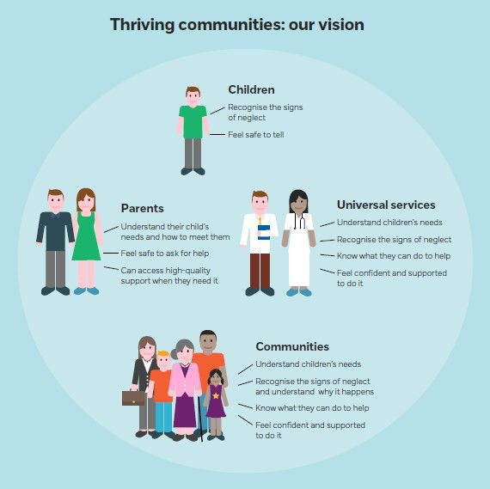

[1]

It is recognised that a concerted shift to prevention where everyone – children, parents, communities, universal services, and partner agencies – work together to help children thrive, preventing neglect before it happens and supporting families early as a preventative process is ultimately the vision for our communities in Dudley

**Introduction**

**What is neglect?**

Neglect is the most common form of abuse.

• 1 in 10 children in the UK have been neglected.

• Concerns around neglect have been identified for half of children who are the subject of a child protection plan or on a child protection register in the UK

• The number of police recorded child cruelty offences is increasing

. • Neglect is the most mentioned form of abuse by adults contacting the NSPCC helpline.

• Less than 1% of Childline counselling sessions are about neglect, possibly because children often don’t recognise their experience as neglectful.

• Younger children are more likely than older children to be the subject of a child protection plan in England because of neglect, although research suggests that the neglect of older children is more likely to go overlooked [2]

Neglect is a serious issue and can compromise a child’s development across several domains. There is evidence that demonstrates the adverse effect of neglect on all the seven dimensions of development including health, education, identity, emotional and behavioural development, family and social relationships, social presentation, and self-care skills1. Therefore, early identification and timely intervention are extremely important to ensure the safety, wellbeing and continued appropriate development of children and young people. Dudley is committed to tackling the issue of neglect effectively and this strategy will inform the planning and actions needed to do so.

**It is important to remember that neglect can be fatal to the child**.

"The majority of neglect related deaths of very young children involve accidental deaths and sudden unexpected deaths in infancy where there are pre-existing concerns about poor quality parenting and poor supervision and dangerous, sometimes unsanitary, living circumstances which compromise the children's safety …. these issues include the risks of accidents such as fires and the dangers of co-sleeping with a baby where parents have substance and/or alcohol misuse problems." [3]

**Purpose and scope**

The purpose of this document is to outline the aims and objectives, key principles, and the strategic action plan for Dudley’s approach to dealing with neglect. It takes into consideration the statutory definition, current picture of neglect in Dudley and the practical aspects of addressing the issue which includes engagement and training of frontline staff and enhancing their understanding and skills to enable identification of those at risk of neglect, early recognition of neglect and timely intervention.

Dudley has priorities about neglect across the life course and in that it is hoped to address the issue in preparing and supporting young people transitioning into adulthood and beyond. This will help to address the inter-generational cycle of neglect and improve outcomes for those adults affected by neglect as a child.

**Neglect by Secondary Carers**

This strategy relates only to the child's primary carers. Neglectful care may also be found in secondary carers such as childminders, foster carers, day care, education or residential settings and faith groups. In this situation concerns should be reported to:

* The child's primary carers, so that they can take appropriate action to protect their child.
* The Designated Officer in Social Care and
* The registration authority for the secondary carer (for example Ofsted), who can consider the possible implications for other children.
* In the case of emergencies see page 32

**Strategic aim**

The strategic aim is to prevent and reduce neglect and to ensure the safety and wellbeing of children and young people in Dudley. In order to fulfil the aim, it is imperative that neglect is prevented, recognised early and that all agencies involved in the care of children in Dudley work together in partnership and have a uniform, consistent, timely and appropriate response to a child considered to be at risk of physical, emotional neglect or abuse.

**Objectives**

1. Improved strategic commitment to understanding neglect, service need and provision

2. Improved awareness and recognition of neglect underpinned by common language, approach

3. Prevent and minimise the incidents of neglect and improve the effectiveness of responses to neglect including assessment

4. Improved use of the Graded Care Profile 2 (GCP2) assessment tool including the antenatal version

5. Improved community participation, including voice of children and young people

**Key principles**

**The strategy rests on the following guiding principles:**

**a) Enabling a shared understanding of neglect and that the safety and wellbeing of children and young people is a priority issue.**

**b) There must be a shared understanding of the consequences of neglect and effects on child’s health, safety and development including the impact of emotional neglect.**

**c) Early recognition of neglect followed by timely assessment and intervention.**

**d) A uniform, consistent and integrated approach from all agencies and effective collaboration between them includes effective information sharing to inform.**

**e) Early help approach to improve the safety of children and young people.**

**f) Recognition of the overlap between neglect and other forms of child maltreatment such as domestic abuse and substance misuse etc.**

**g) Recognition that children with special educational needs and disabilities are potentially more vulnerable to abuse and neglect**

**h) Ensuring a ‘whole family approach’ is adopted by all stakeholders.**

**i) Periodic assessment of progress made by families and work with children and young people to be measured by its impact on outcomes.**

**j) Appropriate statutory action to be taken if sufficient progress has not been made and existing support and intervention have not been successful in addressing the level of risk present.**

**k) Professionals must be curious and inquisitive about circumstances and events using the GCP2 assessment tool to assess any concerns regarding neglect. They should feel confident to challenge families and each other about the sustainability of any improvements required. Historical information must be considered to inform the present position and identify families at risk of intergenerational neglect. Professionals must focus on what is happening not why it is happening.**

**l) The views of service users to be taken into consideration and lessons should be learned from experiences of families, children and young people living with neglect.**

**Neglect – The picture in Dudley [4]**

(NB the figures reflect the period up to Feb 2022 and are not updated during the life of the strategy i.e. 2022-2024)

**Referrals**

**69,594**

Children aged 0-17 years living in Dudley Borough in 2020

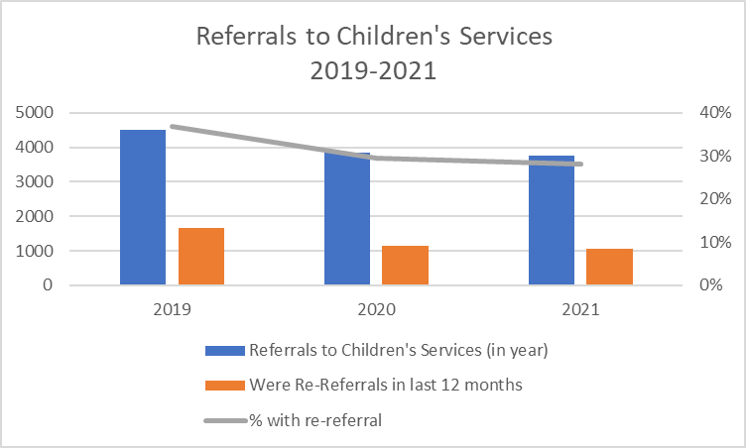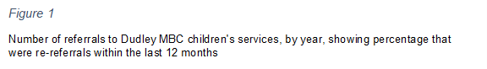

* The overall number of referrals to children’s services is showing a decreasing trend including re referrals
* 28% of referrals were re-referrals in the last 12 months which is a decrease from 30% in 2020 and 37% in 2019

**3765**

Referrals to children’s services in 2021

**1,056**

Were re-referrals in last

12 months

**Children in Need**

**2,287**

Open cases (Feb 2022)

**298**

Open cases with a disability (Feb 2022)

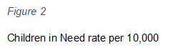

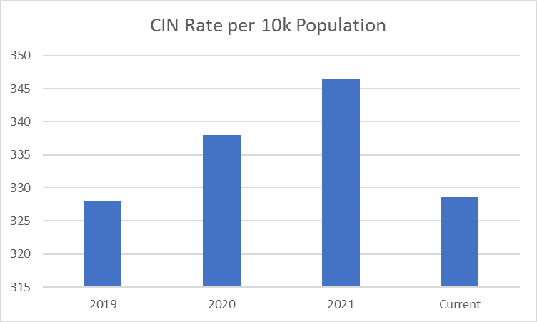

**Children Looked After (CLA)**

**594**

Children looked after by the local authority

Feb 2022

A child or young person who is “looked after” is in the care of the local authority. They can be placed in care voluntarily by parents struggling to cope, they can be unaccompanied migrant children; or in other circumstances, Dudley Children’s Services and partners will intervene because the child or young person is at risk of significant harm.

*Figure 3*

Children Looked after rate per 10,000

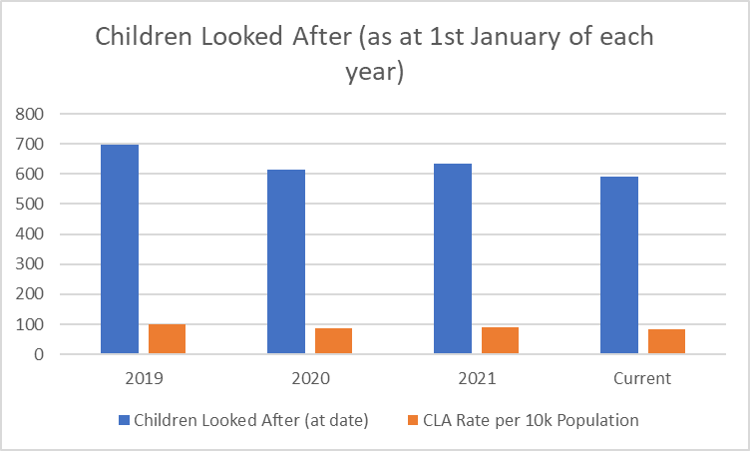

* 593 children were looked after as of 1st March 2022, a rate of 85.1 per 10,000 children.
* These rates have been steadily decreasing since 2014, when the rate was 112 per 10,000 children.
* The 2022 rate is still significantly higher than the England average of 67 children but on a par with the West Midlands average of 85 per 10,000 child population.[5]

**Child protection**

Children who have a Child Protection Plan (CPP) are in need of protection from either neglect, physical, sexual or emotional abuse; or a combination of one or more of these. The CPP details the main areas of concern, what action will be taken to reduce those concerns and by whom, and how professionals, the family and the child or young person (where appropriate) will know when progress is being made.

**1,101**

Child protection investigations in Feb 2022

**318**

Children subject to a child protection plan in Feb 2022

*Figure 4*

Rate of children who were the subject of a child protection plan as of 31st March per 10,000 children

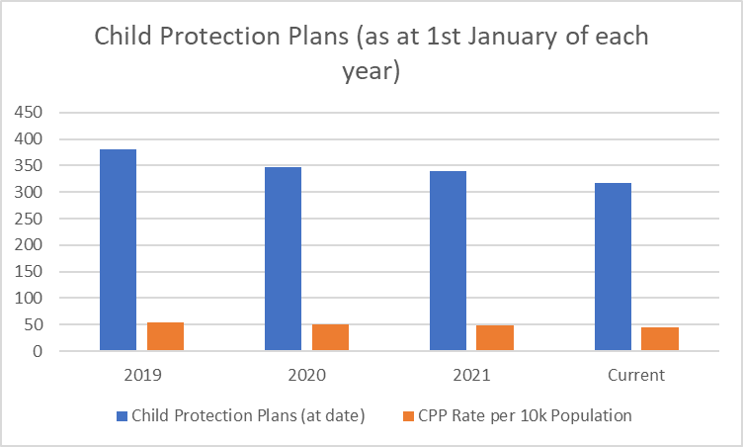

* 318 children were subject to a CPP in Dudley in February 2022 which was a decrease from 340 in 2021, 348 in 2020 and 381 in 2019. As can be seen children subject to CPP are decreasing year on year. In the main this is due to the stronger application of thresholds in arranging Initial Child Protection Case Conference.
* The rate per 10,000 children in Dudley in 2021 was 45 which is marginally higher than England at 41 and that of West Midlands at 43 but decreasing year on year as is reflected above.

*Figure 5*

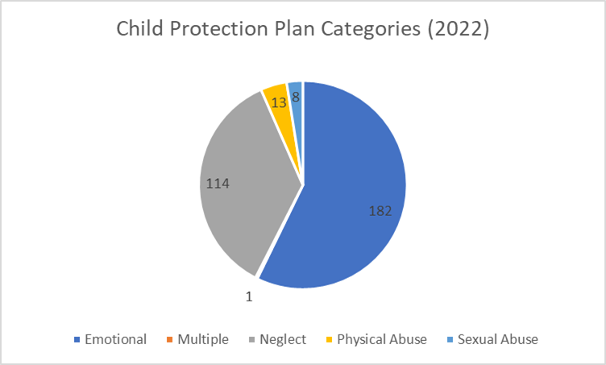

• Emotional abuse is the highest category in Dudley followed by neglect. It can be argued that emotional abuse is neglectful parenting therefore neglect will feature in emotional abuse cases.

**Neglect – The national picture**

In 2013 the NSPCC worked with the University of East Anglia to undertake a systematic analysis of neglect in serious case reviews in England between 2003 and 2011 to explore the circumstances in which neglect can be catastrophic and have a fatal or seriously harmful outcome for a child.

It looks at how risks of harm accumulate and combine and the points at which intervention might successfully have helped to contain these risks.

The research found that:

• Neglect is much more prevalent in serious case reviews than had previously been understood (neglect was present in 60% of the 139 reviews from 2009-2011)

• Neglect can be life threatening and needs to be treated with as much urgency as other categories of maltreatment

• Neglect with the most serious outcomes is not confined to the youngest children, and occurs across all ages

• The possibility that in a very small minority of cases neglect will be fatal, or cause grave significant harm, should be part of a practitioner's mind-set

• Practitioners, managers, policy makers and decision makers should be discouraged from minimising or downgrading the harm that can come from neglect and discouraged from allowing neglect cases to drift

• The key aim for the practitioner working with neglect is to ensure a healthy living environment and healthy relationships for children

**Neglect from a community perspective - What children, families, communities, and practitioners said.**

Using participatory approaches over 600 people were engaged on our journey to better understand what neglect means to our children, families, and communities. Engagement took place with young people, front line officers, decision makers, family centre staff, schools, community volunteers, faith groups and local residents.

14 young people aged between 14 and 21 were trained in participatory appraisal training and used these approaches to help undertake our research.

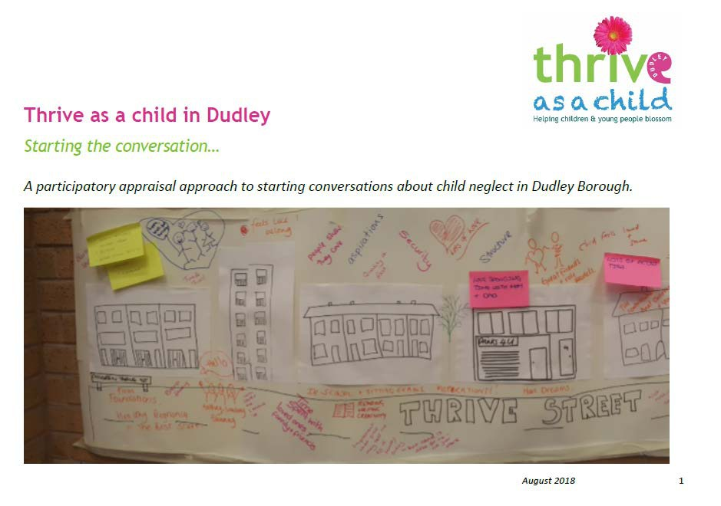

Four questions were asked:

What helps children and young people thrive?

What stops children and young people from thriving? What is child/young person neglect?

What do you think would help children and young people thrive in Dudley?

**Findings**

The following findings were drawn from the participatory appraisal approach:

• The issues are very complex so single messages will not work

• Child neglect is not a children specific issue but often a sign of a wider problem within a family, community, or area.

• It’s not just about children – children are part of families and often extended families

• Important to consider how different cultures view what neglect is and different religious and cultural expectations

• Choice is key: Line of enquiry – did the child have breakfast vs did the child want breakfast and was it available.

• Listening to personal experience is hugely important – services need to reflect what people are saying

• Both adults and children need to know where to go for support

• There needs to be a focus on helping people to thrive rather than neglect

**What is neglect?**

**Definitions**

Neglect is very difficult to define as there are no clear cross-cultural standards for best or

‘good enough’ child-rearing practices.

Society generally believes there are necessary behaviours a caregiver must provide a child for the child to develop physically, socially, and emotionally. Although there can be an individual incident of neglect it is very important to notice patterns of neglectful behaviour rather than one off incidents.

Working Together to Safeguard Children2018 defines Neglect as:[6]

*The persistent failure to meet a child’s basic physical and/or psychological*

*needs, likely to result in the serious impairment of the child’s health or*

*development. Neglect may occur during pregnancy as a result of maternal*

*substance abuse. Once a child is born, neglect may involve a parent or carer*

*failing to:*

* *provide adequate food, clothing and shelter (including exclusion from*
* *home or abandonment)*
* *protect a child from physical and emotional harm or danger*
* *ensure adequate supervision (including the use of inadequate caregivers)*
* *ensure access to appropriate medical care or treatment*

*It may also include neglect of, or unresponsiveness to, a child’s basic*

*emotional needs*

The Government definition revolves around three key concepts:

1. **Persistent failure**. How persistent is persistent? Sometimes how long is too long depends on how old the child is. This has been widely demonstrated by the neurobiology studies of the last few years, indicating that children’s organic brain growth as well as the development of synaptic pathways, forming memories and experiences are profoundly affected by neglectful experiences and exposure to neglectful environments. The first most critical period is the first 1001 days of life (from conception to a child’s second birthday). The second more active synaptic activity of the brain occurs during adolescence. Persistent, therefore needs to be considered not only in relation to the length of time children and young people are exposed to such experiences, but also taking into account the extent in which these experiences are:

• Intrusive: the depth by which they impact on the child/ young person’s health and wellbeing.

• Pervasive: the breath/ number of aspects of child development, situations, people, etc. which are being affected.

As well as in relation to:

• The cumulative impact of individual experiences. Hindley and colleagues’ systematic review of risk factors for the recurrence of maltreatment highlights the cumulative nature of neglect since it is the most likely form of maltreatment for a child to re- experience.[7]

• The frequency, type and intensity of parental neglectful actions (acts of omission).

• The meaning of the child/ young person for the parent/ carer/family; holding the child responsible for the problem (acts of commission).

• The absence of change.

2. **Likely to.** Predicting likelihood requires a good knowledge of child development, observation skills, an understanding of parenting and parenting capacity and the application in practice of relevant research.

3. **Serious impairment***.* This needs to be measured not only in relation to the impact of individual neglectful experiences but also the cumulative impact of those experiences on children and young people. ‘The main theories that have helped us to understand the

way in which cumulative harm impacts on children are child development (including early

brain development), trauma and attachment theories. Researchers investigating brain development have used the term ‘toxic stress’ to describe prolonged activation of stress management systems in the absence of support. Cumulative harm may be caused by an accumulation of a single adverse circumstance or event, or by multiple different circumstances and events. The unremitting daily impact of these experiences on the

child can be profound and exponential, and diminish a child’s sense of safety, stability

and wellbeing [8]

As well as the statutory definition, it is important to have regard to the specific needs of children that are often subsumed under the term ‘failure to meet basic needs’. Professor Jan Horwath (2007) identified additional categories to consider.

These include:

• **Medical neglect** – this involves carers minimising or denying children’s illness or health needs, and failing to seek appropriate medical attention or administer medication and treatments including dental treatment

• **Nutritional neglect** – this typically involves a child being provided with inadequate calories for normal growth. This form of neglect is sometimes associated with faltering growth in which a child fails to develop physically as well as psychologically. However, failure to thrive can occur for other reasons, independent of neglect. More recently, childhood obesity resulting from an unhealthy diet and lack of exercise has been considered as a form of neglect, given its serious long-term consequences.

• **Emotional neglect** – this involves a carer being unresponsive to a child’s basic emotional needs, including failing to interact or provide affection, and failing to develop a child’s self-esteem and sense of identity. Some authors distinguish it from emotional abuse by the intention of the parent.

• **Educational neglect** – this involves a carer failing to provide a stimulating environment, show an interest in the child’s education at school, support their learning, or respond to any special needs, as well as failing to comply with state requirements regarding school attendance.

• **Physical neglect** – this involves not providing appropriate clothing, food, cleanliness and living conditions. It can be difficult to assess due to the need to distinguish neglect from deprivation, and because of individual judgements about what constitutes standards of appropriate physical care. [9]

• **Lack of supervision and guidance** – this involves a failure to provide an adequate level of guidance and supervision to ensure a child is physically safe and protected from harm. It may involve leaving a child to cope alone, abandoning them, or leaving them with inappropriate carers, or failing to provide appropriate boundaries about behaviours such as under-age sexual activity or alcohol use. It can affect children of all ages9. Parental supervision includes consideration for the child’s safety according to the child’s age and ability including the ability to anticipate potential dangers/risks and take appropriate action as well as the ability of parents to hold a child and their needs in mind, anticipating these needs and responding appropriately (being re-active and pro-active as required).

These observable factors relate to children’s developmental needs including health, education, emotional and behavioural development, identity, family and social relationships, social presentation, and self-care skills.

**Recognising child neglect**

**Signs and indicators**

There’s often no single indicator that a child is being neglected. You may notice more than one sign and your concerns might become more frequent if problems are mounting up. This could indicate that a child and their family need support.

Children who are neglected may:

* live in an unsuitable home environment, for example in a house that isn’t heated throughout winter
* be left alone for a long time
* be smelly or dirty
* wear clothing that hasn’t been washed and/or is inadequate (for example, not having a winter coat)
* seem particularly hungry, seem not to have eaten breakfast or have no packed lunch/lunch money.

They may suffer from poor health, including:

* untreated injuries
* medical and dental issues
* repeated accidental injuries due to lack of supervision
* untreated and/or recurring illnesses or infections
* long term or recurring skin sores, rashes, flea bites, scabies, or ringworm
* anaemia.

Babies and young children may:

* have frequent and untreated nappy rash
* be failing to thrive (not reaching developmental milestones and/or not growing at an appropriate rate for their age).

A child who is experiencing neglect may display unusual behaviour, or their behaviour may change. You may notice or become aware that a child:

* has poor language, communication, or social skills
* withdraws suddenly or seems depressed
* appears anxious
* becomes clingy
* is aggressive
* displays obsessive behaviour
* shows signs of self-harm
* is particularly tired
* finds it hard to concentrate or participate in activities
* has changes in eating habits
* misses school
* starts using drugs or alcohol
* isn’t brought to medical appointments such as vaccinations or check-ups.

**Risk and vulnerability factors**

Any child can suffer neglect, but research shows that some children are more vulnerable including those who:

* have a disability
* are born prematurely or with a low birth weight
* have complex health needs
* are in care
* are seeking asylum.

All families come under pressure from time to time. Although many parents are able to provide loving care for their children during difficult periods, increased or continued stress can affect how well a parent can look after their child.

Research shows that parents with a low income, or living in poorer neighbourhoods, are more likely to feel chronically stressed than other parents and parents who are facing complex problems such as domestic abuse or substance misuse can struggle to meet their children’s needs

If parents are feeling particularly isolated, this can make it harder for them to ask for help and increases the risk of child abuse or neglect .[10]

**Poverty and the relationship with neglect**

Major reviews of children’s social care in England and Scotland have affirmed that family poverty and inequality are key drivers of harm to children.

Economic shocks increased abuse and neglect except when families were protected by welfare benefits. This is substantial new evidence for a contributory causal relationship between the economic circumstances of families and CAN [child abuse and neglect] (March 2022)

The gender, age, ethnicity, and health or disability of children and parents influence the ways in which adverse economic conditions affect family life.

It is now widely accepted that ‘poverty is a contributory causal factor in CAN’[11]

Children are more likely to be living in poverty than adults. Over 30% of all children in the UK are currently living in poverty. Family poverty is closely associated with other factors related to abuse and neglect, such as parental mental health and domestic violence.

Dudley has less children living in poverty than the national figure with 21.1% of those under 16 living in absolute low income and 25.7% of children living in relative low income in 2019/20 but it is an increasing trend which is likely to increase with the cost of living rises.

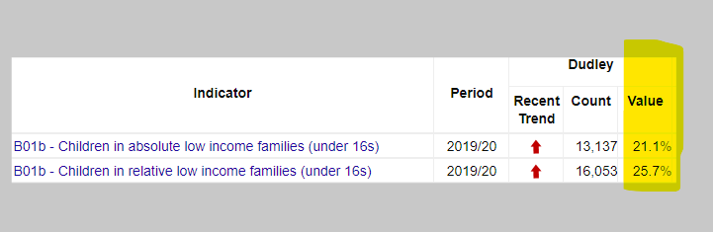

"Nearly half of children in lone parent families live in poverty, compared with one in four of those in couple families.  Of the working-age adults, lone parents are by far the most likely of any family type to be struggling with poverty. ..." [12]

‘poverty … impacts on every aspect of family life’ [13]

Inequalities in care rates between local authorities linked to socio-economic conditions have been widening in the UK over the past 14 years [14] Successive studies in the UK countries [15] have reported that a child in the most deprived decile (10%) of small neighbourhoods is over ten times more likely to be on a child protection plan (CPP) or in out of home care (CLA) than a child in the least deprived decile, both markers of CAN.

The negative economic consequences of the pandemic, which have been particularly severe for families in poverty and disadvantaged groups, have led to concerns about the potential impact on CAN. Mixed evidence is emerging internationally about trends in actual rates of CAN during the pandemic. Recent administrative data for England for the year to April 2021 shows a continuing slight fall in CPPs and entries to care, in line with previous years. There are three possible reasons for this: the unprecedented temporary government support for family finances and businesses together with local community action may have mitigated the economic effects; there may be a delay in the time it takes for trends to be seen in the data and/or there may have been changes in the levels of under-reporting. At the time of writing, it is impossible to reach secure conclusions about the impact of the pandemic.[16]

**Poverty proofing assessment**

Work is developing to implement a poverty proofing assessment across the system as a poverty mitigation measure.

**Affluent neglect**

Neglect is often associated with families from lower socio economic demographics with strong evidence that children living in environments of deprivation and social inequalities are at higher risk for neglect than children from more privileged backgrounds) however one area often hidden and unchallenged is neglect in affluent families. Social class is not routinely recorded when collecting child protection data and most studies generally show that neglect is more likely to come to the attention of the authorities when it involves families from lower socio-economic groups, and that middleclass and affluent families are not subjected to the same amount of state scrutiny The literature thus suggests that there may be biases in the reporting of maltreatment by higher social classes

Research on affluent neglect highlights the following risk factors:

* disconnect between some affluent parents and their children
* many affluent parents do not spend enough quality time with their children and put excessive pressure on their children to be high achievers, and that such factors create psychological and emotional problems for the children in
* the issue of neglect in affluent families is made more complex because of differing values. For example, Luthar and Crossman (2013) noted that affluent parents have a more relaxed attitude to drug use, sexual activity, and sexuality, and as a consequence their children are exposed to more risks
* although children may be living in affluent households, they may also be affected by parental alcohol and substance abuse, and domestic violence. There is often assumption that such problems only occur in poor families
* Typically, it is thought that some affluent parents are often emotionally disconnected from their children because they work very long hours, which means that their children are often left alone, or with a range of paid carers (Luthar and Latendresse 2006). Such situations raise complex questions about how to assess the psychological and emotional availability of parents
* Watson (2005) asserts that wealthier families may have the material resources to hide physical and supervisory neglect while being psychologically or emotionally neglectful. This point is key to understanding why neglect may go undetected in affluent families[17]

It is important for practitioners to understand the complexities of affluent neglect and feel confident through support via supervision to address these issues. Use of the GCP2 assessment tool can also assist to highlight neglectful situations.

**Mental health outcomes**

Child maltreatment (including abuse, neglect and exposure to violence in the home through witnessing or experiencing domestic abuse) has lifelong consequences; it represents a significant environmental risk for normal psychological and biological development often affecting children’s ability to control their emotions and behaviour. The longer experiences persist, and the later risk is escaped, the worse the outcome for children’s mental health 28. Studies have shown strong associations between all forms of maltreatment in childhood and a range of poorer child outcomes including depression, anxiety, post-traumatic stress, suicide, self-injury, severe and persistent behavioural problems, school failure, increased

risk taking i.e., use of drugs and alcohol, sexual exploitation and crime3 29.

**Adverse childhood experiences and relationship to poor outcomes**

Adverse child experiences (ACEs) are an increasing international concern. ACEs arise from abuse and neglect of children and growing up in households where they are exposed to issues such as domestic violence or individuals with alcohol and substance misuse. There is a growing body of evidence that experiences during childhood have an effect on health of the individual throughout the life course. Children who experience stressful and poor-quality childhoods are more likely adopt health harming behaviours during adolescence which can then lead to mental health issues and diseases such as cancer, heart disease and diabetes

later in life. ACEs not only have an adverse effect on health but affected individuals are more

likely to perform poorly in school, more likely be involved in crime and ultimately less likely to be a productive member of society.

People who experience ACEs as children often end up trying to raise their own children in households where ACEs are more common. Such a cycle of childhood adversity can lock successive generations of families into poor health, abusive and anti-social behaviour for generations.

Preventing ACEs can improve outcomes across the whole life course, enhancing individuals’

well-being and productivity while reducing pressures and costs on public sector services10.

**Preventing abusive head trauma**

Abusive head trauma (AHT), which includes shaken baby syndrome, is a preventable and severe form of physical child abuse that results in an injury to the brain of a child. AHT often happens when a parent or caregiver becomes angry or frustrated because of a child’s crying. It is caused by violent shaking and/or with blunt impact. The resulting injury can cause bleeding around the brain or on the inside back layer of the eyes leading to long term health implications or death.

Whilst AHT is categorised as physical abuse it can also be seen as neglectful parenting where available strategies are not used by parents.

AHT due to a crying baby is preventable with support mechanisms in place. One mechanism adopted in Dudley is ICON <https://iconcope.org/>

ICON supports families and professionals with strategies to soothe, calm and support at times of excessive crying to prevent AHT and help them cope with parenting.

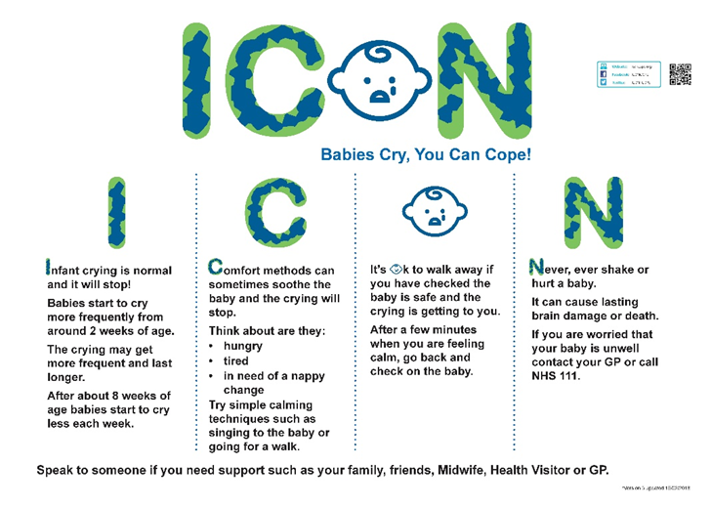

**Neglect in special groups: SEN and children with disability**

The NSPCC suggests that the neglect of disabled children has been invisible. The heightened vulnerability to neglect of disabled children was measured and found to be 3.8 times more likely to be neglected[18], for many reasons including stretching the family’s capacity to be able to care; not being able to communicate their needs[19] and in part due to traits the child brings to the relationship with the parent[20] Kennedy and Wonnacott (2005)[21] emphasise the importance of addressing ‘disabling barriers’ including discrimination; lack of service provision; pity for carers affecting judgment; and the perception that a disabled child is somehow worth less. Brandon et al (2008)[22], in their review of Serious Cases warn of the

‘start again syndrome’, where practitioners, overwhelmed by the complexity of the family, put aside knowledge of the past and focus on the present, supporting parents to make a fresh start. Any new or re-assessment of a family must take into account the family’s history in order to make sense of the present.

**Neglect in adolescents**

Neglect in the teenage years is no less harmful yet is often overlooked or misinterpreted by professionals. They can be divided into two significant age groups 10-14 and 15+ years of age. Some behaviours that have been reported to characterise neglected adolescents are:

• Difficulty solving problems.

• Lack of creativity and language skills.

• Relatively easy onset of frustration or anger.

• Poor and/or inconsistent school achievement.

• School absences leading to school dropouts.

• Arriving early to and leaving late from school, avoiding going home.

• Withdrawn or passive OR Hyper alert and watchful.

• Low self-esteem, anxiety, depression, prone to suicide.

• Inability to trust or overly compliant.

• Lack of recognition regarding Nutrition.

• Drug and Alcohol abuse and early sexual activity.

• Anti-social behaviour, young people getting into trouble; and violent conduct.

• Lack of attention to medical needs.

Adolescents may also find their home situation too difficult to bear and end up running away, further putting themselves at risk for even more dangerous situations, for example exploitation, sexual exploitation, and domestic abuse. The interaction of agencies who work with the adolescents needs to be joined up and often creative, working to include the parents/carers and the young person. The work needs to focus upon facilitative parenting, supporting the development of life skills leading to safe independent living[23].

A programme of joint targeted area inspections (JTAIs) began in January 2016. The programme brought together four inspectorates – Ofsted, Care Quality Commission (CQC), HMI Constabulary and Fire & Rescue Services (HMICFRS) and HMI Probation (HMIP) – to ‘examine how well agencies are working together in a local area to help and protect children’. Each set of JTAIs focuses in depth on a particular issue. One JTAI programme, which began in May 2017, examined the multi-agency response to older children who are experiencing neglect.

As children get older, it is expected that for them to take more responsibility for their actions. This is an important part of a child’s development from childhood to adulthood. However, older children still need a great deal of parental care, support, and guidance. Parenting older children requires different skills, as does working with older children. Evidence was seen in the JTAI of professionals across agencies who lacked the skills and training to work with older children as effectively as they could.

**Presenting behaviours and risks in the context of neglect**

The JTAI found when neglected children present to agencies with a range of problems, such as exhibiting offending behaviour, having suffered exploitation and/or misusing substances or having mental health difficulties or a combination of these many issues, professionals sometimes lose focus on the underlying causes of these problems. They found that professionals did not always look at the whole child, their history and home circumstances in order to understand presenting behaviours and risks in the context of neglect.

Professionals sometimes focused on the behaviour of the child and lost sight of them as a vulnerable child in need of appropriate parenting including affection and support, as well as clear boundaries. The impact of this is that agencies focus on the presenting issues without either addressing neglect in the home or the impact of neglect on the child. Decision making then becomes reactive to the child’s behaviour or particular events in their life rather than being proactive in tackling the underlying cause – neglect.

**Case**

In the case of an adolescent girl, professionals focused on keeping her physically safe from domestic abuse being committed against her by her boyfriend. While her immediate physical safety was undoubtedly important, planning and interventions were not informed by the significant history of neglect or the child’s experiences of physical and sexual assault. This meant that professionals did not address the impact of her traumatic experiences of neglect on her emotional well-being, her sense of self-worth or her ability to recognise risk. The likely success in achieving long term change was therefore limited.

Local safeguarding partners are encouraged to ensure sustained mutual challenge to secure the very best local practice; develop responses informed by what older children tell you about what works; and adopt a continuous learning and improvement culture in local responses to this challenging area of multi-agency practice.[24]

Growing up neglected: a multi-agency response to older children July 2018

**Responding and Assessing**

**Preventing neglect**

There is growing consensus, backed by a wide body of research, that providing children and families with help before a problem emerges or at an early stage prevents children from suffering unnecessary harm, improves their long-term outcomes and is more cost effective than reactive services[25]

Neglect can be prevented and stopped once it starts[26]. At one time or another, all parents face difficulties in their lives that can make parenting hard but providing timely and high-quality advice, support and interventions for parents can in many cases prevent these difficulties leading to neglectful parenting and children experiencing harm as a result.

Children and young people can be protected from possible neglect by identifying circumstances which put parents or caregivers under stress and getting them the right help at the right time. Preventing child neglect needs action from everyone including parents, communities, universal services, and government to work together to keep children safe and help them thrive. Parents may be dealing with complex problems that directly impact on their ability to meet their children's needs which may include domestic abuse, drugs and alcohol misuse and mental health problems. External factors such as financial problems and poor housing or homelessness can make it more difficult for parents to meet their children’s needs.

**Giving children a voice**

It’s vital to build safe and trusting relationships with children so they can speak out about any problems they are experiencing. This involves teaching children what neglect is and how they can get help.

**Early Help**

Once concerns are identified, early help can be provided by universal services or by targeted specialist services. Practitioners working in universal health, community, education, and a variety of other services have a key role to play in providing early help for neglect. Ways in which practitioners can provide early help include:

• Talking to a child and their parents or carers about the concern, in order to understand the unmet need.

• Collecting information about a child and their family.

• Identifying which services are best placed to help a family by initiating an early help assessment or other assessment framework.

• Monitoring a child’s situation.

• Providing direct practical and emotional support to a child and/or their parents.

Signposting families to other specialist services where necessary.

A range of specialist services can provide early help to prevent child neglect as well as support families after neglect has been identified. Specialist services include social services, housing services, drug and alcohol services and support from voluntary organisations.

Early Help services can also be provided to families through a range of evidence-based programmes that aim to improve parenting practice.

**Parenting - Assessment and intervention**

Improved parenting is the cornerstone of child maltreatment treatment and prevention Stevenson (2007)[27] suggests *“there are six pre-requisites for a good enough assessment of parenting:*

• Knowledge of evidence on specific effects of parental issues on caregiving e.g. substance misuse, learning disability.

• Ongoing regular re-appraisal of the situation.

• A realistic picture about the parents’ will to change.

• Realistic expectations of what is ‘good enough’ parenting.

• Identification of individual needs.

• Impact of poverty as an integral part of the assessment, not just a ‘context’ but as a daily stressor.

The provision of evidence-based parenting programmes are important because they aim to ensure that support provided to families is based on sound theory, research and experience of what works best. Two parenting programmes rank particularly highly. These are

'Incredible Years [28] and are particularly potent when run in early childhood and in group format. Triple P is the parenting programme provided in Dudley for families identified as needed additional support.

**Enabling communities to support families**

Building community resilience and using strength-based community approaches are an important foundation for supporting our children and young people.

Communities have an important role to play in preventing and intervening early in child neglect and adverse childhood experiences. To make a difference, we need to make sure everyone in our communities can recognise the signs of child neglect, understand why it happens and what they can do to help, feel confident and supported to help and know how to find help if they are experiencing difficulties in their own family.

Preventing neglect and safeguarding children is ‘everyone’s businesses’. This message needs to be communicated widely and communities must be empowered to recognise and address neglect. This message is reinforced via the Know More Campaign endorsed by Black Country Child Death Overview Panel as messages to prevent neglect and child death. This campaign is fluid, dynamic and can be expanded with new themes.

<https://dudleysafeguarding.org.uk/children/parents-and-carers/campaigns/>

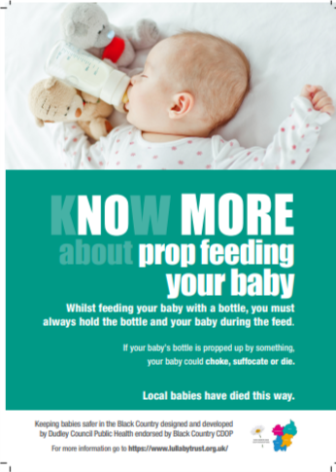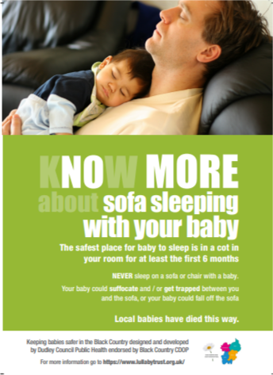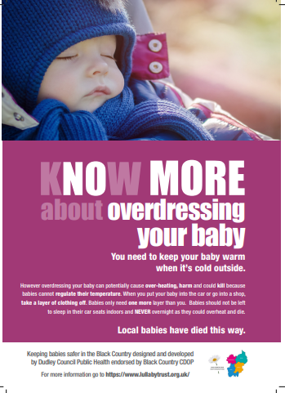

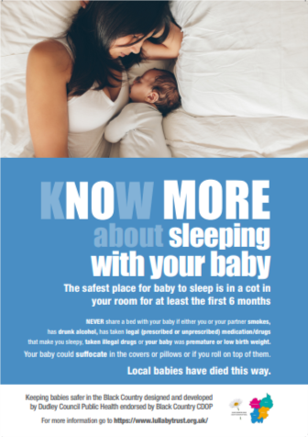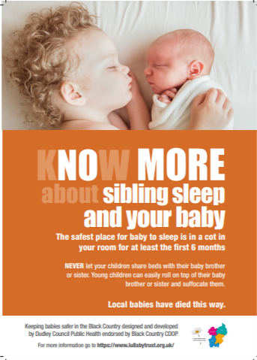

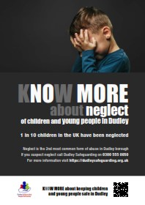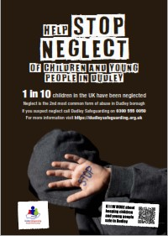

**Neglect assessment**

Working Together (2018) states that the assessment of neglect cases can be difficult as neglect can fluctuate both in level and duration. Practitioners should rigorously assess and monitor children at risk of neglect to make sure they’re adequately safeguarded over time and plans should be reviewed regularly to analyse whether sufficient progress has been made to meet the child’s need

Following a thorough scoping exercise of neglect assessment options, the previous Dudley Safeguarding Children Board adopted the NSPCC Graded Care Profile 2 (GCP2) as the assessment tool to be used across the children’s workforce in Dudley. The use of the licensed tool provides an evidence based, tested approach recognised nationally and used across the region.

* Where neglect is suspected by any agency a GCP2 should be undertaken as soon as possible.
* Only practitioners who are specifically trained and licensed in GCP2 can use the assessment.
* Any child on a child protection plan for neglect should have a GCP2 and associated improvement plan

|  |
| --- |
| **Impact Evaluation - what difference did the GCP2 make to the child/family?** |
| The GCP2 has made a huge positive impact to this family. They have recognised the need for improvement in home conditions and have recognised that there was a need for change within their parenting.  Parents recognised that once they had made positive changes, they were able to observe positive changes in the children maintaining their own environments and also the children’s behaviour.  The family home is now a clean and safe place to live. The children now have improved sleeping arrangements and have nurturing, welcoming bedrooms to sleep in.  The children are parented fairly and consistently and this has had a positive impact on their behaviour and emotional wellbeing.  **Family Centre Support Worker** |

Partner agencies have received single agency agreements to embed the GCP2 and GCP2A (where applicable) into practice and provide accountability to DSPP.

The NSPCC have recently developed an antenatal version of GCP2 known as GCP2A to assess neglect concerns displayed by pregnant women. Dudley are part of a current national pilot programme after being part of the development team.

**GCP2 Antenatal pathway**

A new pathway has been developed to give clarity of when and who will undertake the GCP2 antenatal assessment.

**What will make a difference?**

**Preventing child neglect**

By identifying circumstances that put parents and carers under stress and getting them the right help at the right time, people who work with children can protect them from possible neglect.

Protective factors that can reduce the risks to children’s wellbeing include:

* a strong social support network for the family
* income support, benefits and advice
* good community services and facilities[29]

The three key building blocks (fig 1) that underpin actions to prevent neglect are:

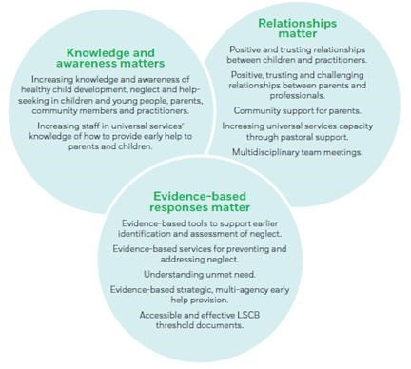

[30]

**What do we have in place to recognise and respond to neglect?**

W

All agencies providing opportunities or services to children and young people are able to recognise and respond to neglect. Once a neglect concern is raised a GCP2 should be undertaken.

**Universal services**

**GP, Maternity services, health visitors, school nurses, dentists, Emergency Department, Pediatricians, mental health services, education providers, neglect training pathway, Five to Thrive movement and voluntary organisations**

**Early help**

**Triple P programmes, GCP2 and GCP2A as improvement plans, Specialist clinical pediatric services requiring a referral and speech and language services.**

**Child Safeguarding processes**

**GCP2 and GCP2A assessments**

**Training pathway**

DSPP offer a pathway of neglect training with GCP2 at the heart of the training to understand and assess where neglect is suspected. All practitioners providing services to children and young people should attend neglect training and GCP2 training with maternity services, pre-birth teams and appropriate family solutions staff accessing GCP2 antenatal. Those practitioners who provide services for adolescents should attend the responding to adolescent neglect training.

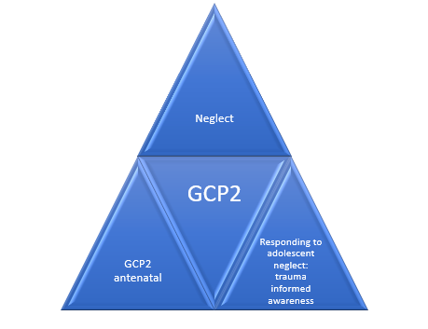

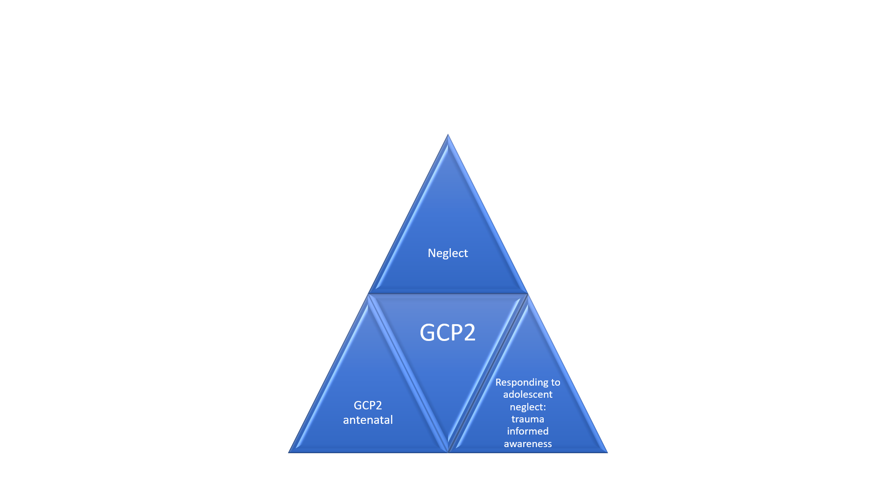

**Responding to child neglect**

**Reporting**

**If you think a child is in immediate danger, contact the police on 999.**

**If you're worried about a child but they are not in immediate danger, you should share your concerns.**

* Follow Dudley’s child protection procedures[**https://www.dudley.gov.uk/residents/care-and-health/safeguarding/tell-us/**](https://www.dudley.gov.uk/residents/care-and-health/safeguarding/tell-us/)
* If you are GCP2 trained undertake an assessment to evidence your concerns and provide an improvement plan. If you are not trained get some help from a colleague who is trained. A GCP2 assessment must be completed where concerns of neglect are present.
* Contact the NSPCC Helpline on [0808 800 5000](tel:08088005000) or by emailing [help@nspcc.org.uk](mailto:help@nspcc.org.uk). Trained professionals will talk through your concerns with you and give you expert advice.

Services will risk assess the situation and take action to protect the child as appropriate either through statutory involvement or other support.

**Recording concerns**

Neglect is a long-term pattern of behaviour. Adults who are concerned that a child’s needs are not being met should record individual incidents to build up an overview of the child’s lived experience. These records should be shared with other agencies as appropriate and used to decide what support a child and their family need.

**Assessing neglect**

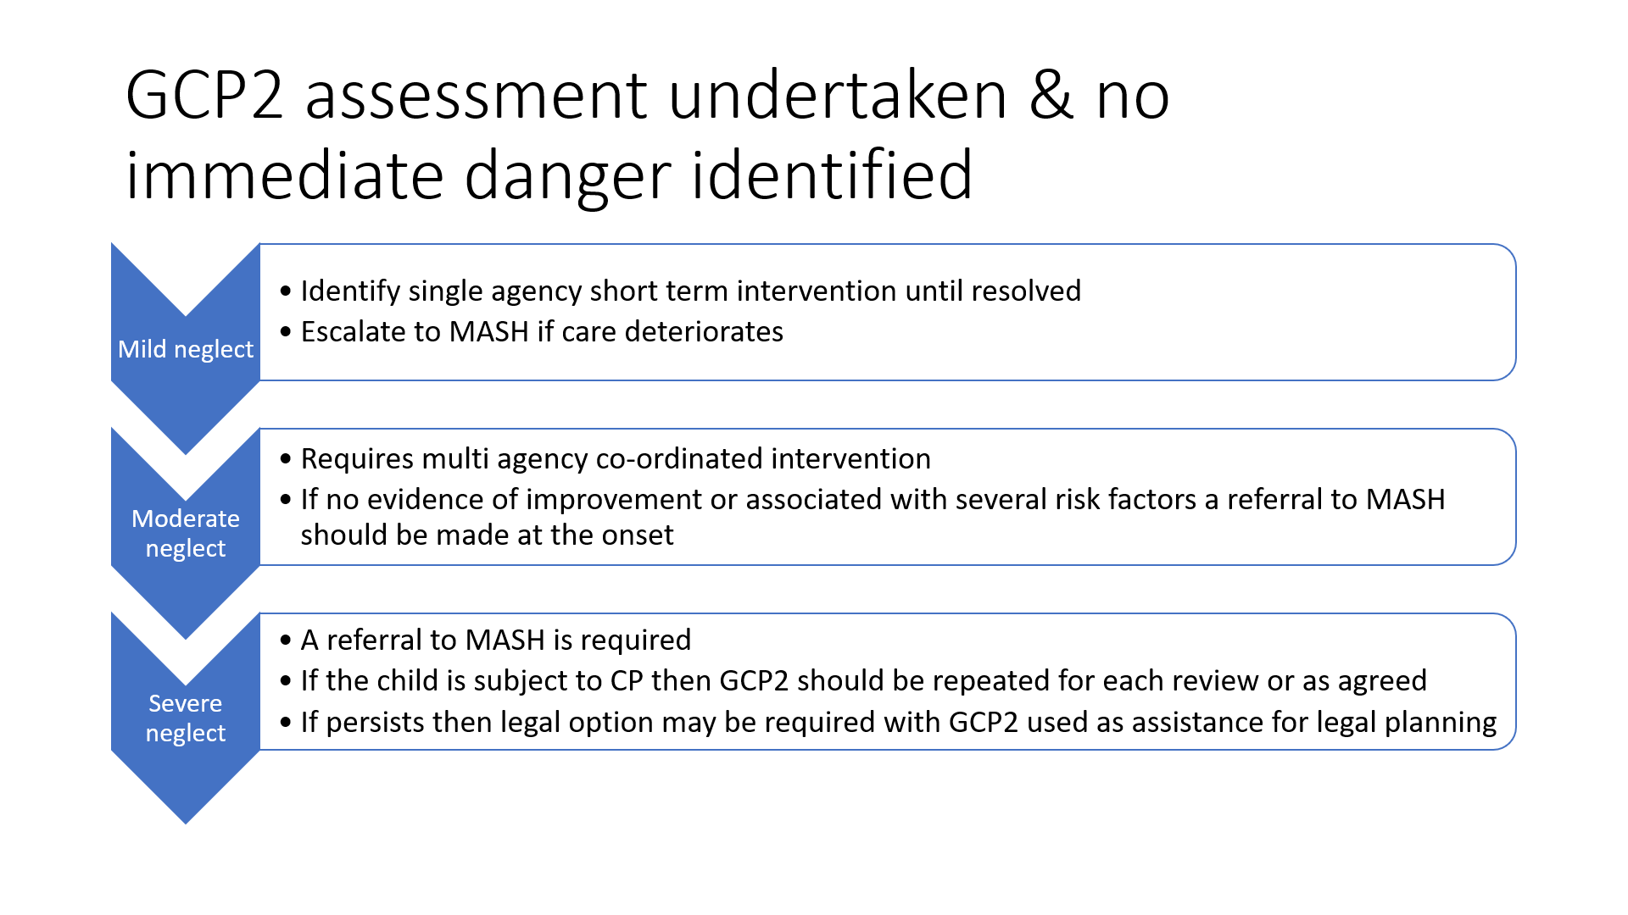Assessment tools can help practitioners get a clear picture of how well parents are able to look after their children. This helps professionals make timely evidence-based decisions to improve the child’s quality of life. As previously mentioned, Dudley has adopted the Graded Care Profile 2 (GCP2) assessment tool which helps professionals measure the quality of care a child is receiving. The NSPCC has evaluated GCP2 and found that it’s successful in helping to identify neglect. **Ofsted’s guidance and recommendations on addressing Neglect**

In its March 2014 report “In the child’s time: professional responses to neglect”, Ofsted

suggests that local authorities should:

• Ensure that there is robust management oversight of neglect cases, so that drift and delay are identified and there is intervention to protect children where the risk of harm or actual harm, remains or intensifies.

• Prioritise the training and development of front-line practitioners, focusing on the skills needed to engage in direct work with families and the development of good assessments that describe what life at home is like for children.

• Support social workers and managers in the use of models and methods of assessment that enable them to effectively describe and analyse all risk factors in cases of neglect and then take decisive action where this is required.

• Prioritise the development and use of plans to support and protect children suffering from neglect, ensure that those plans set out clearly, with timescales, what needs to change and the consequences of no or limited change; plans should be subject to routine management oversight given the complexity of work with neglected children.

• Ensure that social workers have specialist training and supervision to enable them to exercise professional authority and challenge parents who fail to engage with services, particularly when their children are subject to child protection plans; this process should be subject to robust, regular management oversight and practice audit.

• Ensure that there is clarity about the threshold for care proceedings to be initiated in cases of neglect, and that the threshold is understood, consistently applied, and monitored by local authority social care staff, senior managers, and their legal advisers.

• Oversee the written evidence presented to courts so that it is clear, concise, and explicitly describes the cumulative impact of neglect on the daily life of the child.[31]

**Priorities for action**

Prevention, early recognition, and management of neglect is a priority in Dudley and building on the strategic priorities, our priorities for action are:

Improved strategic commitment to understanding service need and provision

• A collective commitment to tackle neglect across the partnership and demonstration of effective leadership in driving forward changes required.

• Cross fertilisation of this strategy into relevant strategies, policies such as Emotional Health and Wellbeing Strategy, Parenting Strategy, Early Help Strategy, Healthy Child programme, Better Births etc.

• Senior management commitment and support to sign up to the vision and aims and objectives of this strategy.

Improved awareness understanding and early recognition of neglect underpinned by common language approach.

• Comprehensive training offer - induction through to targeted, including bespoke training as needed to meet the needs of the most vulnerable children including adolescent and children with special needs and disabilities.

• Prioritise social care workforce and those working with the most vulnerable groups.

• Develop multimodal communication approaches to raising awareness of neglect targeted in a range of settings including schools.

* Identify children at risk of neglect at the earliest opportunity and undertake GCP2 assessment

Prevent, minimise incidents of neglect and improve the effectiveness of responses to neglect

• Mandatory assessment tool adopted for Dudley (Graded Care Profile 2) for prevention, identification and to support intervention.

* Evidence of the right intervention at the right time to reduce risk and support families to find solutions

• Robust data capture system in place to monitor patterns of neglect to help inform prevention, early intervention and early help approaches.

• Ensure prevention of neglect is given equal priority to addressing neglect through implementation of evidence-based programmes for example parenting and early help.

• Improvement in the quality of the multi-agency response to children and families living with neglect captured though case reviews, audit and voice of children and families.

• Professionals receive effective supervision to prevent drift and delay and develop their confidence and ability to analysis risk to children and young people.

* Effective use of the multi-agency escalation policy will evidence concerns and improvements made as a result

Improved community participation, including voice of children and young people

• Build upon the community participatory work and recommendations to shape further engagement and dialogue with communities on neglect.

• Focus on a community strengths-based approaches to include ‘Five to Thrive’ and restorative practice.

• Capture the outcomes of children and families through case studies demonstrating voice of child at centre of decision.

* Every agency will be able to evidence how they are capturing the voice/experience of the child including the use of GCP2 with the child and using this in their service delivery response to neglect

1. NSPCC2016
2. NSPCC 2021
3. Brandon et al, 2013
4. All local data is sourced from Dudley Councils Intelligence, Performance & Policy Team
5. DFE national statistics
6. Working Together to Safeguard Children 2018
7. Hindley, N., Ramchandani P.G., Jones, D.P.H., (2006), Archives of Disease in Childhood, Risk Factors for Recurrence of Maltreatment: A Systematic Review, Volume 91, Issue 9, 744-752, 2006
8. Bromfield, L. and Miller, R. (2007) Specialist Practice Guide: Cumulative Harm. Melbourne, Vic: Department of Human Services, State Government Victoria.
9. Horwath, J. (P) (2007) The Neglected Child: Identification and Assessment. London: Palgrave.
10. Jütte et al, 2014); Haynes et al, 2015
11. Bywaters et al., 2016a, p.33
12. via - https://www.jrf.org.uk/data/overall-uk-poverty-rates 2022 UK Poverty report
13. Mason et al., 2021a, p.7
14. Bennett et al., 2020a
15. Bywaters et al., 2020
16. Source: The Relationship Between Poverty and Child Abuse and Neglect: New Evidence March 2022

    Paul Bywaters and Guy Skinner With Aimee Cooper, Eilis Kennedy, Afra Malik
17. Source: An Exploration of How Social Workers Engage Neglectful Parents from Affluent Backgrounds in the Child Protection System Professor Claudia Bernard Goldsmiths, University of London
18. Sullivan, P.M., & Knuton, J.F. (2000). Maltreatment and disabilities: A population-based epidemiological study. Child Abuse & Neglect, 24(10), 1257-1273.
19. Bovarnick, S. (2007) *Child neglect.* NSPCC research briefing*.* London: NSPCC.
20. Howe, D. (2005) *Child abuse and neglect: attachment, development and intervention.* Houndmills: Palgrave Macmillan.
21. Kennedy, M. and Wonnacott, J. (2005) “Neglect of disabled children”. In J. Taylor and B. Daniel (eds). Child Neglect. Practice

    Issues for Health and Social Care.
22. Brandon, M; Belderson, P; Warren, C; Howe; D; Gardner; R; Dodsworth; J; Black; J (2008) ‘Analysing child deaths and serious injury through abuse and neglect: what can we learn? DfES, London
23. Hicks L, Stein M (2010) ‘Neglect Matters’. Department for Children, Schools and Families (DCSF).
24. Growing up neglected: a multi-agency response to older children July 2018
25. Allen, G. (2011). Early intervention: The next steps.An independent report to HM Government. London: Cabinet Office.

    Davies, C. & Ward, H. (2011). Safeguarding children across services: Messages from research. London: Jessica Kingsley Publishers.

    Easton, C., Lamont, L., Smith, R. & Aston, H. (2013). ‘We should have been helped from day one’: A unique perspective from children, families and practitioners.Findings from LARC5. Slough: NFER.

    Field, F. (2010). The foundation years: preventing poor children becoming poor adults – the report of the independent review of poverty and life chances.London, HM Government.
26. Johnson, R. & Cotmore, R. (2015). National evaluation of the Graded Care Profile. London:NSPCC.

    Williams, M. (2015). Evidence-based decisions in child neglect: An evaluation of an exploratory approach to assessment using the North Caroline Family Assessment Scale. London: NSPCC.
27. Stevenson, O. (1998) ‘Neglected Children and Their Families’ (2nd Edition recommended 2007). Blackwell Publishing, Oxford
28. Webster Stratton 1991), and Triple P (Sanders et al. 1999)
29. Cleaver, Unell and Aldgate, 2011
30. NSPCC2015
31. In the child’s time: professional responses to neglect, Ofsted 2014